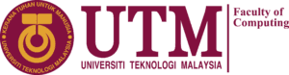
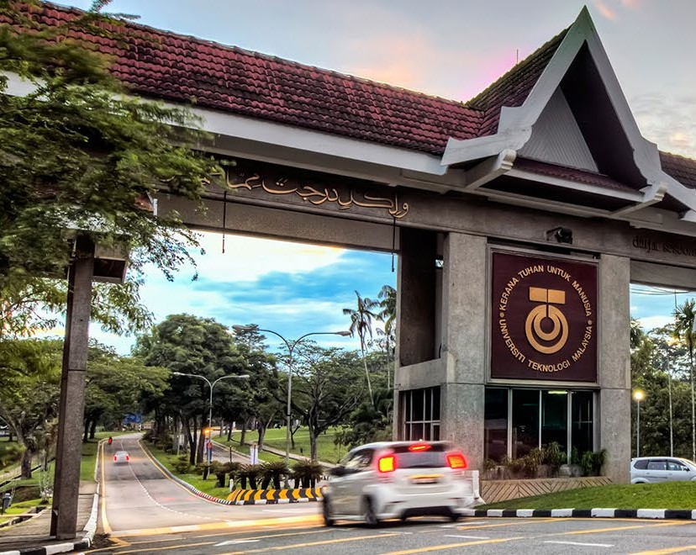


PROGRAM

PROPOSAL
FACULTY
COMPUTING

SEMESTER 2
SESSION 2024/2025

SECD3761
TECHNOPRENEURSHIP SEMINAR

SEMINAR TITLE
TECHNOPRENEURSHIP:
THE STARTUP JOURNEY TO SUCCESS

26th June 2025| 08.00 a.m. – 5.00 p.m.

Mentored by : Assoc. Prof. Ts. Dr. Ramesh Zaidi Rozan
Authored by : Group 1 Section 18


Executive Summary

Organizing Team | - Chau Ying Jia (A23CS0213)  - Cheryl Cheong Kah Voon (A23CS0060)  - Chua Jia Lin (A23CS0069)  - Lau Yee Wen (A23CS0099)  - Poh Lok Yee (A23CS0262)
Programme Details | Title: Technopreneurship: The Startup Journey to Success  Venue: N28A, Kejora Hall  Date: 26th June 2025, Thursday  Time: 08.00 a.m. – 5.00 p.m.  Speaker 1:  Dr. Kavita Ganesan (Malaysian-born AI strategist and the founder of Opinosis Analytics)  Speaker 2:  Ms. See Wai Hun (CEO and co-founder of JurisTech)
Objectives | - To showcase innovative ideas and startups from students and emerging technopreneurs.  - To provide learning opportunities through expert talks, panels, and networking sessions focused on sustainable business growth.  - To foster collaboration between academia, industry, and entrepreneurs for long-term technopreneurial success.
Proposed Budget | RM 5000
Reference/Written by  Signature  Poh Lok Yee  +6011 1151060  poh.yee@graduate.utm.my |  | Verified by  Signature  Chau Ying Jia  +6017 5678907  chau@graduate.utm.my



Table of Contents

Executive Summary 2
1.0 Introduction 4
1.1 Purpose of the Document 5
1.2 Objectives 6
1.3 List of activities 6
1.4 Targeted Audience and Potential Participants 8
1.5 Technical Aspects of the Programme 9
2.0 Guest Speaker Background 10
3.0 Impact of the Programme 12
3.1 Impact to the Organizer 12
3.2 Impact to the Participants 13
4.0 Programme Tentative 14
5.0 Organizing Committee 16
6.0 Proposed Budget 18
7.0 Conclusion 19



1.0 Introduction
In Malaysia’s fast-evolving digital era, the transformation of innovative ideas into impactful and sustainable ventures has become a national priority. The Faculty of Computing has organized an event, themed Technopreneurship: The Startup Journey to Success, offers a dynamic platform to nurture and empower the next generation of local tech entrepreneurs who will drive the nation’s digital economy forward.
The journey of a technopreneur is filled with challenges like the uncertainty, evolving markets, and the constant pressure to innovate. While many young talents possess creativity and technical skills, building a viable and scalable startup demands more than just a good idea. It requires structured guidance, industry exposure, and access to a supportive ecosystem. This showcase is designed to bridge that gap by connecting aspiring innovators with experienced entrepreneurs, ecosystem enablers, and academic mentors.
What sets this event apart is its dual format: a vibrant showcase of student-led innovations and tech solutions, coupled with an impactful seminar featuring successful Malaysian technopreneurs, who will share their real-world experiences, lessons learned, and strategies for building resilient startups. This initiative reflects our commitment to equipping students not only with technical excellence but also with the entrepreneurial mindset needed to succeed in today’s competitive environment.
By fostering collaboration between students, educators, startups, and industry players, the Technopreneurship Showcase 2025 serves as a launchpad for new ideas and a catalyst for sustainable innovation, contributing to Malaysia’s long-term vision of becoming a regional leader in technology and entrepreneurship.



1.1 Purpose of the Document

The purpose of this document is to outline the planning and execution details of our event – Technopreneurship: The Startup Journey to Success, which will be held in conjunction with the Faculty of Computing Technopreneurship 2025 project. This proposal provides a structured overview of the event’s objectives, avtivities, targeted participants, technical requirements and expected outcomes – serving as a comprehensive guide for all stakeholders involved in the event.

The document specifically aims to:
- Define seminar’s core purpose of empowering and educating aspiring technopreneurs through engaging, experience-driven discussions led by successful Malaysian tech entrepreneurs.
- Present a clear list of planned activities and their roles within the broader showcase, highlighting how the seminar complements the exhibition of student innovation and entrepreneurship.
- Identify the target audience including students, early-stage entrepreneurs, academics, and industry professionals, and also outline how their participation will contribute to a vibrant, knowledge-sharing environment.
- Outline the technical, logistical, and coordination aspects necessary to ensure smooth implementation of the seminar, from speaker setup to audience engagement.
- Provide a reference point for the organizing committee, including role distribution, guest speaker background, scheduling, and budget allocation.


1.2 Objectives

- To highlight and promote innovative solutions and entrepreneurial projects developed by students and aspiring technopreneurs within the Faculty of Computing, providing them a platform to share their ideas and get experience and also gani in knowledge with a broader audience and chances.
- To facilitate knowledge- sharing sessions through seminars, and interactive discussions with experienced industry professionals, focusing on practical insights into building, managing and growing sustainable tech startups.
- To strengthen connections and encourage collaboration between academic institutions, industry stakeholders and budding entrepreneurs, contributing to the development of a resilient and future-ready technopreneurship ecosystem in Malaysia.

1.3 List of activities

The Technopreneurship: The Startup Journey to Success seminar is one of the core components
of the Faculty of Computing Technopreneurship Showcase. The following is a list of planned activities that will take place throughout the event:

- Opening Ceremony
A formal opening session by Dr Zaidi introducing the event theme and objectives.

- Technopreneurship Seminar
A knowledge-sharing session by our invited guest speakers who will present insights into their startup journeys, challenges, and strategies for success.

- Showcase Booths
Industry showcasing to the youngsters to let them have an idea.



- Networking and Engagement Session
An informal session designed to foster connections among students, speakers, industry representatives, and faculty members to encourage future collaboration and mentorship.

- Panel Discussion and Q&A
An interactive dialogue session between the guest speakers and audience, where participants can ask questions, share views, and learn from real-world startup experiences.

- Closing Remarks and Token of Appreciation
A brief session to conclude the seminar and express gratitude to guest speakers, organizing committee members, and participants for their contributions and support.



1.4 Targeted Audience and Potential Participants

This seminar is designed to attract a diverse group of people who have a shared interest in innovation, entrepreneurship, and the development of Malaysia’s digital economy. The targeted audience and potential participants include:
- All Undergraduate and Postgraduate Students
Particularly those from the Faculty of Computing and others who are interested in entrepreneurship, startups, or innovation-based projects.
- Aspiring Technopreneurs
Individuals or student teams who are currently developing startup ideas, prototypes, or business models and are seeking guidance, inspiration, or networking opportunities.
- Academic Staff and Researchers
Lecturers and researchers who are engaged in innovation, commercialization, or entrepreneurship-focused teaching and mentorship.
- Industry Professionals and Startup Founders
Invited guests from the tech industry and startup ecosystem who may serve as speakers, mentors, or potential collaborators for student-led innovations.
- Tech Enthusiasts
Open to individuals who have a keen interest in technopreneurship, especially those looking to engage with the local startup scene or support young innovators.



1.5 Technical Aspects of the Programme

To ensure a smooth and professional seminar experience, several key technical aspects have been carefully planned and will be monitored throughout the event.

The seminar will take place at Dewan Kejora, located in N28A, which accommodates up to 150 participants and is equipped with central air-conditioning and accessible facilities. The venue setup includes a main stage with a podium, LED screen backdrop, full HD projectors, wireless microphones, high-quality speakers, adjustable lighting, and designated areas for speaker demos. A camera setup will also be used for internal video relay and optional livestreaming. A secure high-speed Wi-Fi network will be provided, with separate channels for guests and the technical team. Laptops with pre-installed AI and startup-related software will be available for demonstrations.

To handle unforeseen disruptions, a technical control station will be in place to monitor and address any real-time issues with audio-visuals or digital tools. Backup microphones, HDMI cables, adapters, and laptops will be prepared to avoid technical downtime.

Participants will check in via a QR code-based digital registration system, and engagement will be encouraged through live feedback platforms such as Slido or Google Forms. E-certificates will be sent to participants after the event.

These technical preparations are designed to ensure a professional, efficient, and engaging seminar experience for all stakeholders, aligning with the innovative and forward-thinking nature of technopreneurship.


Guest Speaker Background

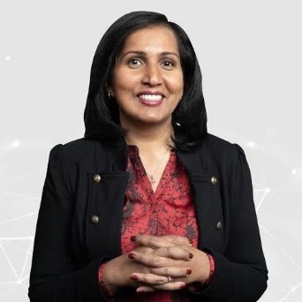

Dr. Kavita Ganesan is a Malaysian-born AI strategist and the founder of Opinosis Analytics, a consulting firm that helps businesses adopt and implement natural language processing and machine learning solutions. She holds a PhD in Computer Science from the University of Illinois at Urbana-Champaign and an MS in Computer Science from the University of Southern California. With over 15 years of experience in the AI field, Dr. Kavita has worked with Fortune 500 companies, and her research has been cited in hundreds of academic and industry papers. Her book, The Business Case for AI, provides actionable strategies for applying AI to real-world problems. Her ability to translate deep technical knowledge into business innovation makes her an ideal speaker for students and aspiring technopreneurs.



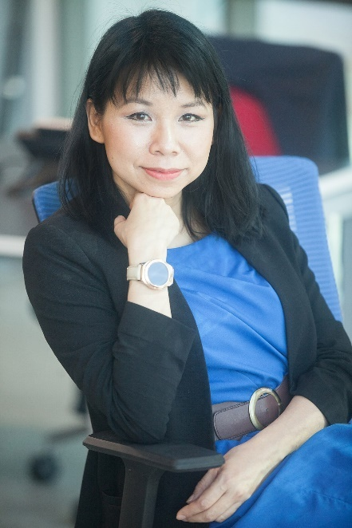

Ms. See Wai Hun is the CEO and co-founder of JurisTech, one of Malaysia’s leading fintech companies specializing in enterprise software for banks and financial institutions. With a degree in Business Computing from the University of Winnipeg, Wai Hun began her career in consulting before launching JurisTech in the wake of the Asian financial crisis. Under her leadership, the company evolved from a startup into a tech powerhouse, winning numerous industry awards. She is frequently invited to speak on topics such as women in tech, startup growth, and the future of financial technology. Her journey exemplifies how strong computing foundations, combined with entrepreneurial vision, can lead to impactful success in the tech industry.


Impact of the Programme

3.1 Impact to the Organizer

Organizing the Technopreneurship: The Startup Journey to Success seminar will serve as a transformative experience for the planning committee and the Faculty of Computing. It will enhance the faculty’s profile as a proactive and forward-thinking hub for innovation, entrepreneurship, and student empowerment. By executing a multifaceted event that combines technical showcases, industry insights, and collaborative engagement, the organizing team will gain hands-on experience in event planning, stakeholder management, and strategic communication.

This event will also help build stronger ties with industry players, alumni entrepreneurs, and academic partners, paving the way for future collaborations, guest lectures, and internship placements. The successful delivery of this seminar will reinforce the faculty’s commitment to producing not only technically skilled graduates but also entrepreneurial thinkers ready to contribute to Malaysia’s digital future. Furthermore, the experience will cultivate leadership, accountability, and problem-solving skills among the student organizers, contributing to their overall academic and professional development.



3.2 Impact to the Participants

Participants of the seminar will gain a rare opportunity to immerse themselves in the real-world dynamics of tech entrepreneurship. Through keynote talks, panel discussions, and networking sessions, they will be exposed to the realities of startup development — from ideation to execution, including funding challenges, market fit strategies, and innovation management.
Student innovators will receive constructive feedback on their projects and business models, helping them refine their ideas and better prepare for market readiness. The presence of established technopreneurs will offer motivational and practical value, inspiring participants with stories of persistence, resilience, and strategic pivots in startup journeys.
Moreover, the event will create a platform for cross-disciplinary learning and community building among students, faculty, and industry leaders. For many participants, the seminar could mark the starting point of their entrepreneurial journey, providing both the knowledge and confidence to take their ideas forward. The exposure and connections formed during the event could lead to mentorship opportunities, startup incubation, or even early-stage investment discussions, further amplifying the long-term impact of the programme.


Programme Tentative

Time |  | Activity | Description
08:00 a.m. | Registration | Participants arrive, register, and receive event kits  including the schedule, speaker profiles, and showcase booklet.
08:30 a.m. | Opening Ceremony | Formal opening session by Dr. Zaidi introducing the event theme, objectives, and significance of  technopreneurship.
09:00 a.m. | Technopreneurship  Seminar  Topic 1: “Bringing AI to Life: Turning Research into Real-World  Solutions”  By Dr. Kavita Ganesan | Inspiring session on bridging academic research with business value, early-stage startup challenges, and  validating AI ideas.
9:50 a.m. | Technopreneurship Seminar  Topic 2: “From Crisis to Code: Building a Fintech Powerhouse in Malaysia”  By Ms. See Wai Hun | Insights into sustainable startup growth, leadership during uncertainty, and adapting to fintech market  dynamics.
10:40 a.m. | Panel Discussion & Q&A | Interactive dialogue between guest speakers and the audience. Participants can ask questions, share views, and learn from real-world startup experiences.
11:00 a.m. | Showcase Booths | Industry and student startup booths open. Participants explore innovations, products, and services.
12:30 p.m. | Lunch Break | Lunch provided. Continued casual interaction among students, speakers, and guests.
02:00 p.m. | Networking &  Engagement Session | Informal sessions encourage meaningful  connections between students, industry  representatives, mentors, and faculty members.
4:30 p.m. | Closing Remarks &  Token of Appreciation | Summary of key takeaways and appreciation ceremony for guest speakers, committee members, and  attendees.
5:00 p.m. | End of Programme | Event ends.




Organizing Committee

The success of this event is the result of the unwavering commitment, collaboration, and dedication of the organizing committee. Each member plays a crucial role with clearly defined responsibilities to ensure the event runs smoothly and achieves its goals.

- Chau Ying Jia

Role: Event Director
Responsibilities: Leads the overall planning and execution of the event. Coordinates across teams, ensures smooth progress of all activities, and monitors deadlines to maintain timeline integrity.

- Lau Yee Wen

Role: Program Coordinator
Responsibilities: Develops the event agenda, liaises with guest speakers and panelists, and ensures smooth flow and time management of sessions on the event day.

- Cheryl Cheong Kah Voon

Role: Technical Coordinator
Responsibilities: Manages all technical aspects including AV setup, equipment functionality, and stable internet connectivity throughout the event.

- Poh Lok Yee

Role: Logistics and Venue Coordinator & Participant Liaison
Responsibilities: Arranges venue setup and coordinates catering services, and oversees participant registration and distribution of event materials. Handles inquiries and ensures participant engagement and satisfaction throughout the event.


- Chua Jia Lin

Role: Marketing and Communication Coordinator
Responsibilities: Leads promotional campaigns, creates marketing content, manages social media and public relations, and communicates with guests and participants.

Support Team

- Amir Zarif bin Ahmad

Role: Assistant Technical Coordinator
Responsibilities: Assists with equipment setup, ensures smooth functioning of audio-visual tools, and supports technical issue resolution during the event.

- Nur Aisyah binti Abu Zikri

Role: Hospitality Coordinator
Responsibilities: Manages refreshments and catering logistics, and ensures the comfort and sati
faction of all attendees and invited guests.

Mentor

- Dr. Zaidi bin Abdul Rozan

Role: Faculty Mentor
Responsibilities: Provides advisory support and academic guidance to ensure the event aligns with the faculty’s educational objectives and professional standards.


Proposed Budget

Item | Cost (RM)
Venue Rental | 500
Technical Equipment
- Projectors and Screens | 300
- Sound Systems | 300
Speaker Honorarium | 1000
Catering
- Morning Tea | 300
- Lunch | 800
- Afternoon Tea | 300
Marketing Materials | 300
Tokens of Appreciation | 400
Printed Materials
- Flyers and Banners | 400
- Event Booklets | 100
Miscellaneous
- Contingency Fund | 300
Total | 5000


Conclusion

The Technopreneurship: The Startup Journey to Success seminar was created to encourage innovation and inspire students to explore entrepreneurship in the tech industry. Through meaningful sessions with experienced speakers, exciting startup showcases, and networking opportunities, this event gave participants valuable insights into what it takes to succeed as a technopreneur in today’s fast-changing digital world.

With support from the Faculty of Computing and guidance from Dr. Zaidi bin Abdul Rozan, the seminar brought together students, educators, and industry leaders in one space to share knowledge and ideas. Keynote speakers like Dr. Kavita Ganesan and Ms. See Wai Hun shared their real-life experiences, giving attendees a clearer picture of the challenges and possibilities in building and growing a startup.

For the organizing team, this event was a chance to develop teamwork, leadership, and event management skills. For participants, it offered exposure to real-world startup journeys, feedback on their own ideas, and the opportunity to connect with experts and potential mentors.

With careful planning, a strong team, and a clear vision, the seminar achieved its goals of promoting entrepreneurship, encouraging collaboration, and supporting the development of future-ready talent. It is our hope that this event will spark more innovation and motivate students to take bold steps in their own technopreneurship journeys.

